Department of Computer Science

Gujarat University

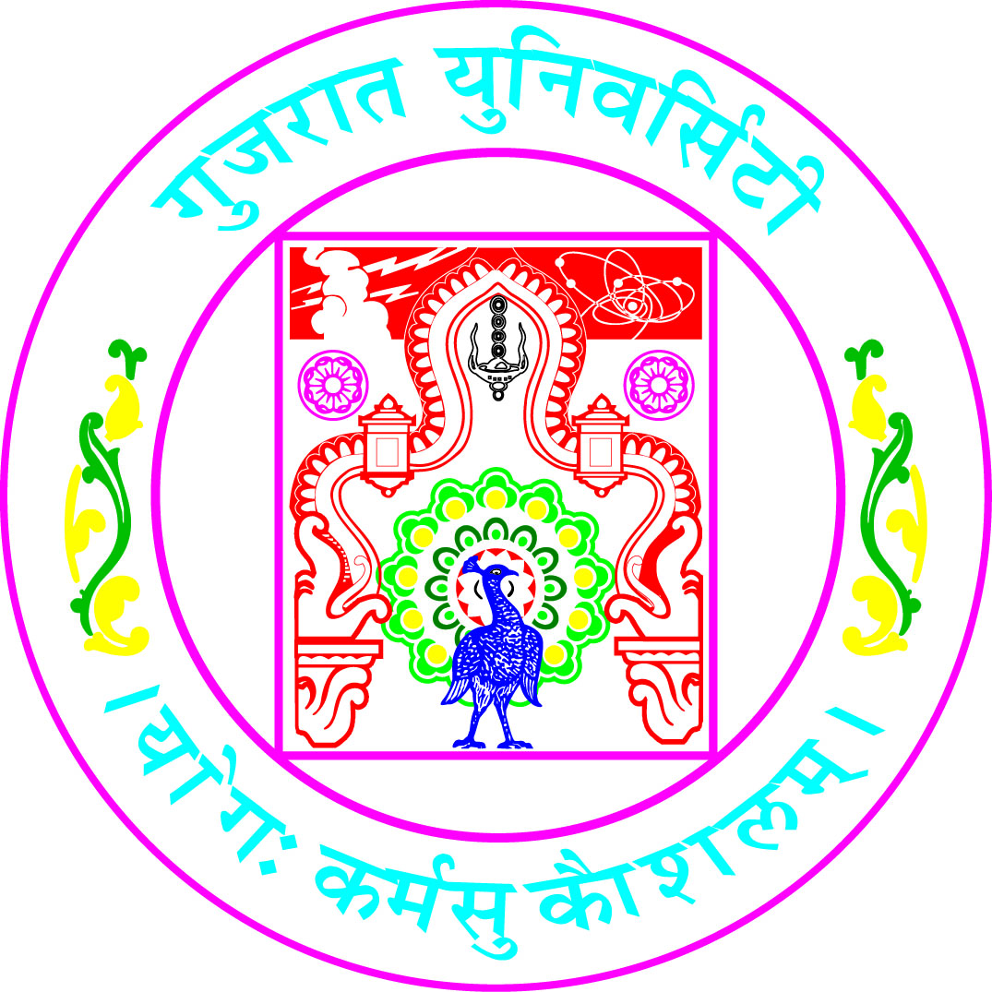

Certificate

Roll No: 13 Seat No: ______

This is to certify that Mr./Ms. ___Antra koul______________________ student of MCA Semester – V has duly completed his/her term work for the semester ending in December 2020, in the subject of ___________Software Engineering________________________ towards partial fulfillment of his/her Degree of Masters in Computer Applications.

11-12-2020
Date of Submission Internal Faculty

Head of Department

